KELUARGA BANI MADNASIR BIN NATA SANTANA DAN MBAH ERUM / IYUNG BINTI H. UMAR (Alm.)

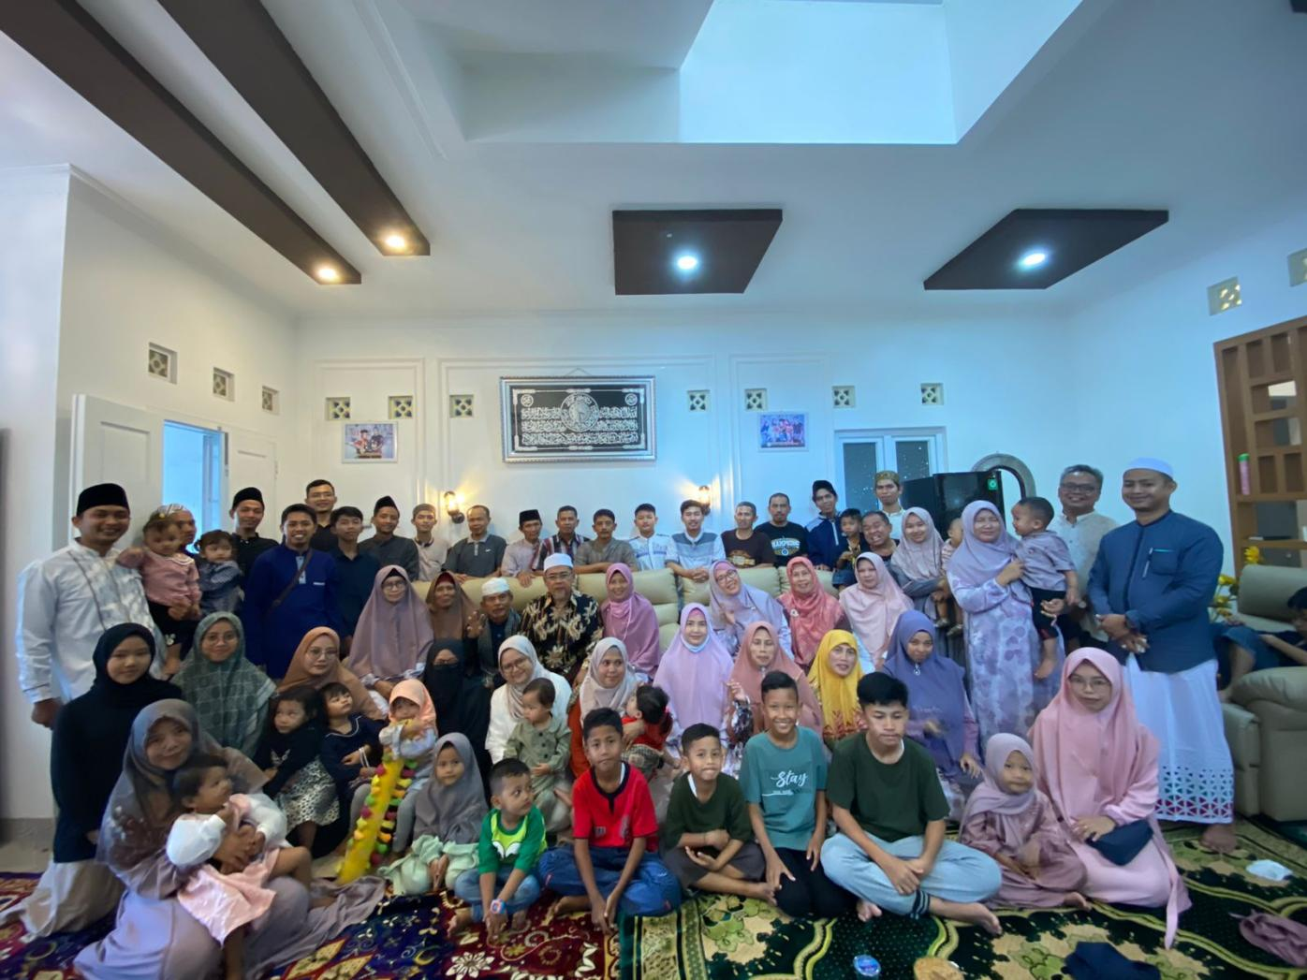
- Bani Hj Oyoh Binti Madnasir & H. Mansyur
- Anak + suami / istri
- Ahmad (Alm.)
- Suparman (Alm.)
- Titin (Alm.)
- H. Ujang Panut Mansyur & Hj. Idah Sayidah
- Ika Siti Fanisa & Otang Suparman
Cucu :
- Mohammad Lutfi
- Sahla Nur Aqilah
- Muhammad Bagir (Alm.)
- Mohammad Nunu Ibnu Malik (Alm.)
- Mohammad Rian Amirudin & Ika Siti Zham’ah
Cucu :
- Salwa Syakira Mardhiyah
- Muhammad Addhiya Syauqi
- Endah Siti Nurjanah & Mumuh Mukhtar Gojali
Cucu :
- Yasmin Kaamila
- Tanzila Yughnillah
- Mohammad Wildan Zakaria
- Nadia Rahma Sakinatuzzahra
- H. Dedi Kardiman & Hj. Neni Sahmianati
- Rizki Ali Zulfikar & Mahdina Permatasari
Cucu :
- Shahnoza Kyna Zulfikar
- Sarfaraz Ziyan Zulfikar
- Rizka Fatwa Maulida & Asep Abdul Azis
- Haifa Razyan Saniha
- Ziyya Gamila Aziza
- Reki Mohammad Romzi Yusuf
- Asikin (Alm.)
- Ida (Alm.)
- H. Didik Sodikin & Hj. Imas Rahmawati
- Awalunisa Istiqomah Rahmadzikri Syabani & Adit Taufik
Cucu :
- Adzkiya Tanzeela Ramadhani
- Tsaninisa Fatimah Rahmadzikrishafira
- Muhammad Yasin Rahmadzikrihabibi
- (Alm.)
- (Alm.)

- Hj. Dedeh Rodiah Mansyur & H. Dedi Junaedi
- Farah Fairuz Fauzia Fernanda
- Shabrina Maulida Agustine
- Neni (Alm.)
- Otong Engkus Kusnadi & Nina Herlina
- Diandra Hasna Fauziah
- Hasbi Muhammad Maulana Yaseer
- Muhammad Aydin Nafis
- Enok Sri Rauyati & K. Mohammad Izzudin
- Mohammad Ridwan Syakir
- Adinda Sya’diyah Mardiyyah & Mafahim
- Salwa Rofiqah
- Rifa Rif’ah Mardiyyah
- Ahmad Hanifah Murtadho
- Tita Susilawati & Apip Hapidin
- Tyasti Zahra Hafidz
- Fahmi Yusran Hafidz
- Iis Siti Nurasiah & Uken Sukendi
- Salma Marsa Zulfah
- Muhammad Rafi Rabbani
- Muhammad Faqih Rabbani
- Emin (Alm.)

- Eha (Alm.)

- Bani Aminah & Tadjudin
- Anak & Suami / Istri
- Yayah Siti Rohayati & Oyo Aspia
- Abiyyu Faris & Puji Fauziah Nur’aeni
Cucu :
- Ulfatun Nisa Awaliyah
- Maulina Nur Aisyah
- Luthfi Hadyan
- Romi Yafi’ Nabilah
- Een Kuraenah & Endung Bukhori
- Otong Madhuri & Lia Daliati
- Putra Wira Madhuri Dixsit
- Septian Gery pratama
- Divanka Madhuri putri
- Nanang Madnan & Dede Rusdiani
- M. Sihabuddin
- Maulida Dwi Oktaviani
- Nining Yuningsih & Taufiqurohman
- Mamah Siti Rohmah (Alm.)
- Didin Syamsudin
- Maman Sulaeman & Ima Mutmainah
- Muhammad Rakha Auliya
- Ammar Madaarisul Hukama

- Momon (Alm.)

- Bani Aat Mulyati & Anan Ahyana
- Anak + Suami / Istri
- Dadah Hamidah & Asep Firdausie
- Shalsabilla Eka Pratiwi
- Dini Rosdiani (Alm.)
- Dina Rosdiana & Dudung Abdul Halim
- Nabilah Qurrotul 'Aini
- Dodi Nazmudin & Pipih Durotun Nafisah
- Muhammad Zaki Al Ghifari
- Nazmi Sa'diatun Nafisah
- Tsabina Nur Latifah
- Diar Romdiniah & Yusuf

- Bani Hj. Maryam ( Hj. Emay) & H. Udin Rosyidin &
- Agus Sathwatulloh & Eem Siti Maimunah
    - Muhammad Falahuddin
    - Ahmad Shofwan Fikrii
    - Abidah Nurul Jannah
- Andi Heryanto & Mumun Maemunah
- Esy Yasirotussalamah
- Muhammad Hilmi Khoirulloh
- Muhammad Faiz Attaftazani
- Aris Setiawan & N.Heni Hanifatur Rohman
- Aang Muhammad Najih Ar-Rosyid
- Muhammad Fairuz Hibatulloh
- Dian Hardiansyah & Elas Siti Sholihah
- Muhammad Badrudin
- Muhammad Maimun Al Munibi
- Nisa Ulpatunnisa & Udin Nasrudin
- Wafiyatun Nur Asyiah
- Almira Husna Humaira
- Muhamad Fajar Sepudin
- Laela Nuranna & Heru Khoerul Muttaqin
- Hafshah Sai'dah Fiddaroeni

